Ormankhan Meiirman
Ex1
1NF requires that every column in a table contain only a single, atomic (indivisible) value per row. In Booking_receipt, the seat_numbers column stores multiple values in one cell when a booking includes several passengers for example "12A, 12B"
booking_id | seat_numbers | ticket_price
101 | 12A,12B | 250
102 | 7C | 120

Ex2
First, we remove ‘seat_numbers’ because a single cell contains multiple comma-separated seats violating 1NF. We create a separate ‘Booking_seats’ table where each seat is a distinct row (consisting of booking_id and seat_number)
Next is 2NF: we don't need to change anything here. Since Booking_receipt has a single key (booking_id) instead of a composite key, it meets 2NF automatically
As for 3NF: the issue is that flight_number, airline_name, airport names, and cities depend on flight_number rather than booking_id directly. Additionally, the city depends on the airport name, not the flight itself. Therefore, we extract these into separate Flights and Airport tables
Booking_receipt: booking_id (PK), passenger_full_name, passenger_passport_number, flight_number (FK), ticket_price
Booking_seats: booking_id (PK, FK), seat_number (PK)
Flights: flight_number (PK), departure_airport_name (FK), arrival_airport_name (FK), airline_name
Airport: airport_name (PK), city
Ex3
booking_id → passenger_full_name, passenger_passport_number, flight_number, ticket_price
flight_number → airline_name, departure_airport_name, arrival_airport_name
departure_airport_name → departure_city
arrival_airport_name → arrival_city

Ex4
Checking the Flights table: the primary key is flight_id, and since it's a single key rather than a composite one, 2NF is satisfied immediately. For 3NF, I checked whether there are any dependencies between non-key attributes—for instance, whether departing_gate depends on departing_airport_id. It doesn't; each flight has its own gate. Plus, the Flights table itself doesn't store airport or airline names, only their IDs (departing_airport_id, arriving_airport_id, airline_id), while the names themselves reside in separate Airport and Airline tables. This means there are no transitive dependencies, so the table is in 3NF
Ex5
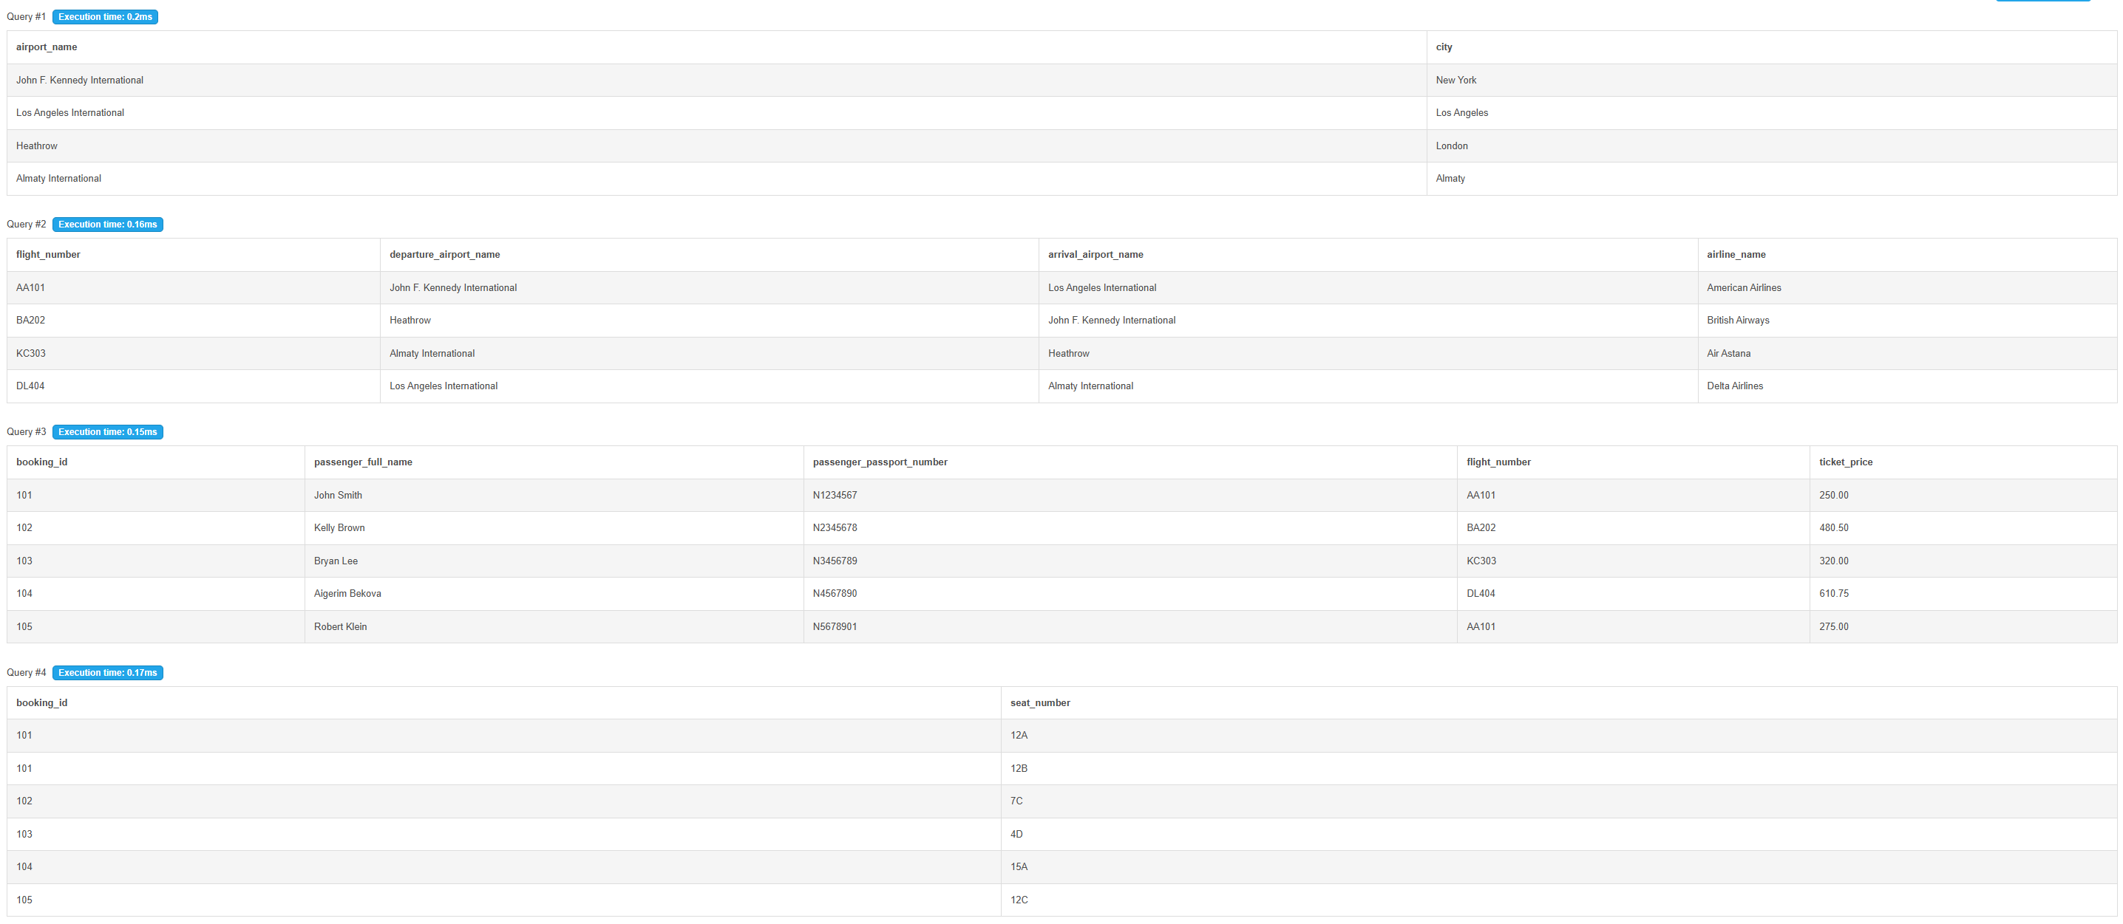

DDL
Create tables
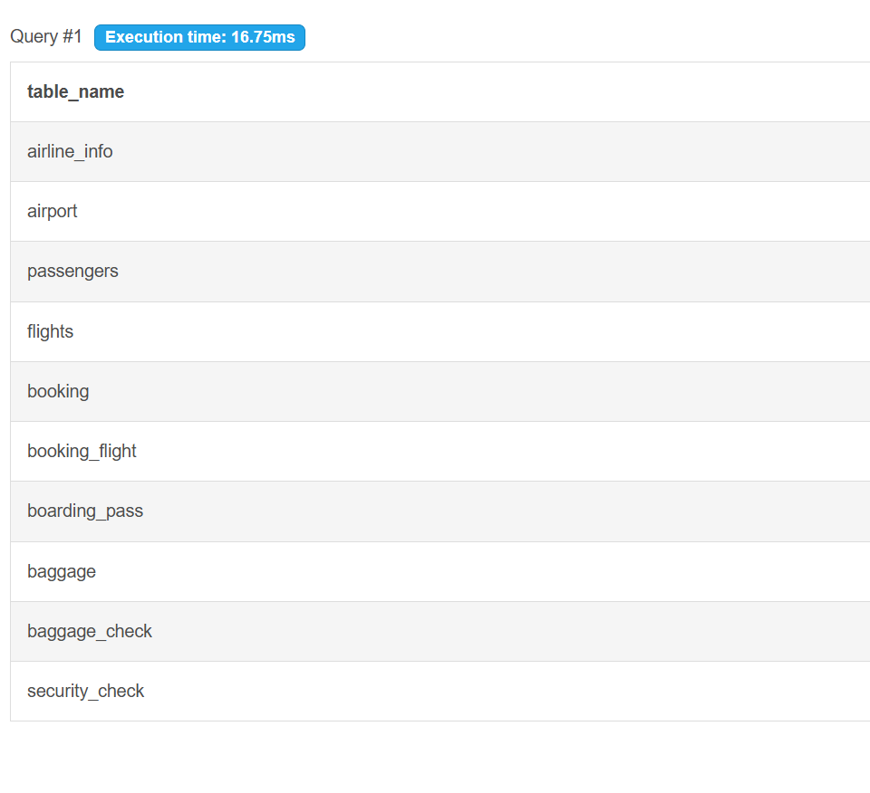
Primary Keys and NOT NULL constraints
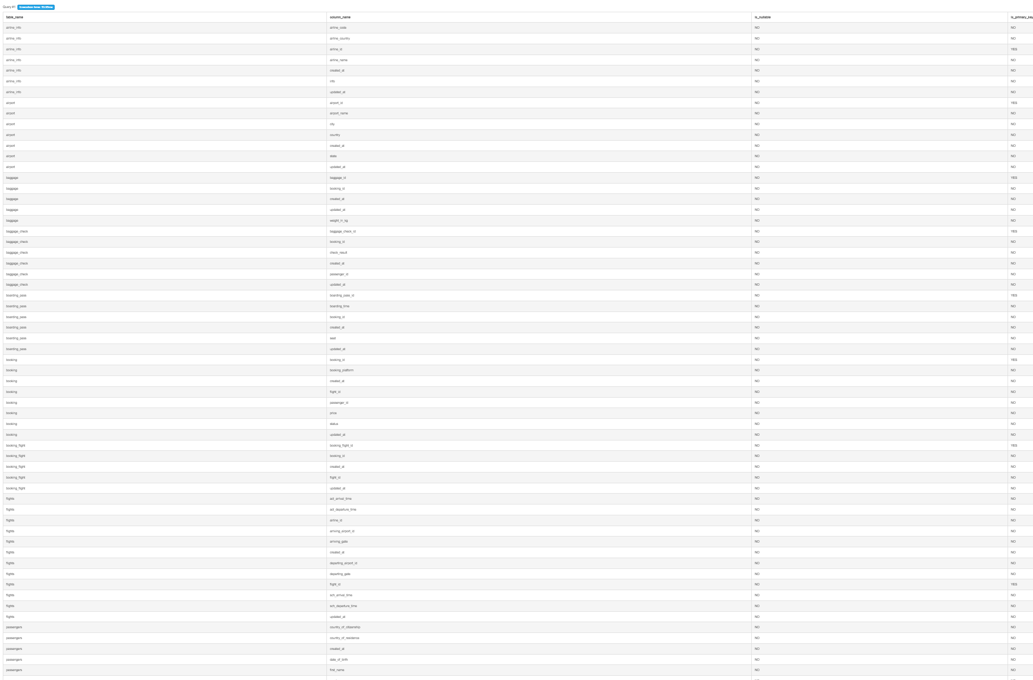
Renaming, data type change, drop column
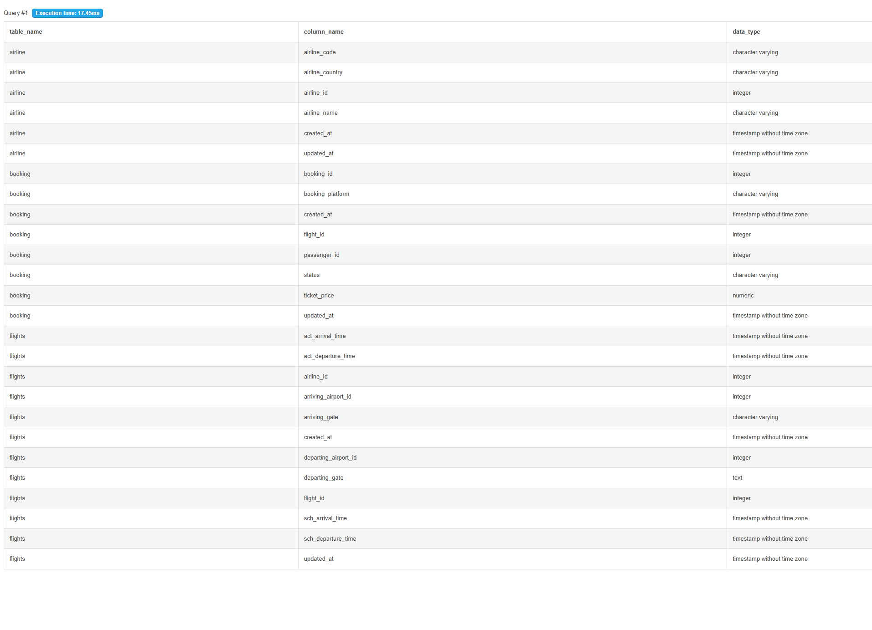
Foreign Keys
